Ex No: 01  Date: | Estimation of Project Cost and Control Activity
Aim
To estimate the total project cost by creating a project schedule, assigning resources with their respective costs, allocating resources to project activities, and calculating the overall project cost using the open-source project management tool ProjectLibre.
Algorithm
- Start ProjectLibre.
- Create a new project.
- Enter the project name and start date.
- Define all project activities with their durations.
- Set dependency (predecessor) relationships.
- Open the Resource Sheet.
- Create project resources.
- Assign Cost Per Use or Standard Rate for each resource.
- Allocate resources to project tasks.
- View the Project Cost Report.
- Observe the estimated project cost.
- Save the project
Procedure
Step 1: Create a New Project
- Open ProjectLibre.
- Click File → New.
- Enter:
  - Project Name: Software Project Scheduling
  - Manager: Your Name
  - Start Date: Select today's date.
- Click OK.

Step 2: Enter Project Tasks
Add all project activities along with their durations.
Task | Duration
Requirement Gathering | 2 Days
Feasibility Analysis | 3 Days
UI/UX Design | 4 Days
Database Development | 5 Days
Application Development | 6 Days
System Testing | 3 Days
Bug Resolution | 2 Days
Project Deployment | 1 Day

Step 3: Define Task Dependencies
Assign predecessors so that each task starts after the previous one is completed.
Task | Predecessor
Requirement Gathering | None
Feasibility Analysis | 1
UI/UX Design | 2
Database Development | 3
Application Development | 4
System Testing | 5
Bug Resolution | 6
Project Deployment | 7

Step 4: Create Resources
Go to Resource Sheet and enter the team members.
Resource | Cost Per Use
Arun Kumar | ₹2,000
Priya Sharma | ₹1,800
Karthik Raj | ₹2,500
Nisha Devi | ₹2,200
Rahul Verma | ₹2,700
Deepika S | ₹2,100
Ajay Kumar | ₹1,900
Meena R | ₹2,300

Step 5: Assign Resources
Assign one resource to each project task.
Task | Resource
Requirement Gathering | Arun Kumar
Feasibility Analysis | Priya Sharma
UI/UX Design | Karthik Raj
Database Development | Nisha Devi
Application Development | Rahul Verma
System Testing | Deepika S
Bug Resolution | Ajay Kumar
Project Deployment | Meena R

Step 6: Calculate Project Cost
- ProjectLibre automatically computes the cost using the assigned resource rates.
- Open the Project Report or Project Information window.
- View the total project cost.

Step 7: Record the Result
From the Project Report:
- Project Duration: 208 Hours
- Estimated Project Cost: ₹17,500

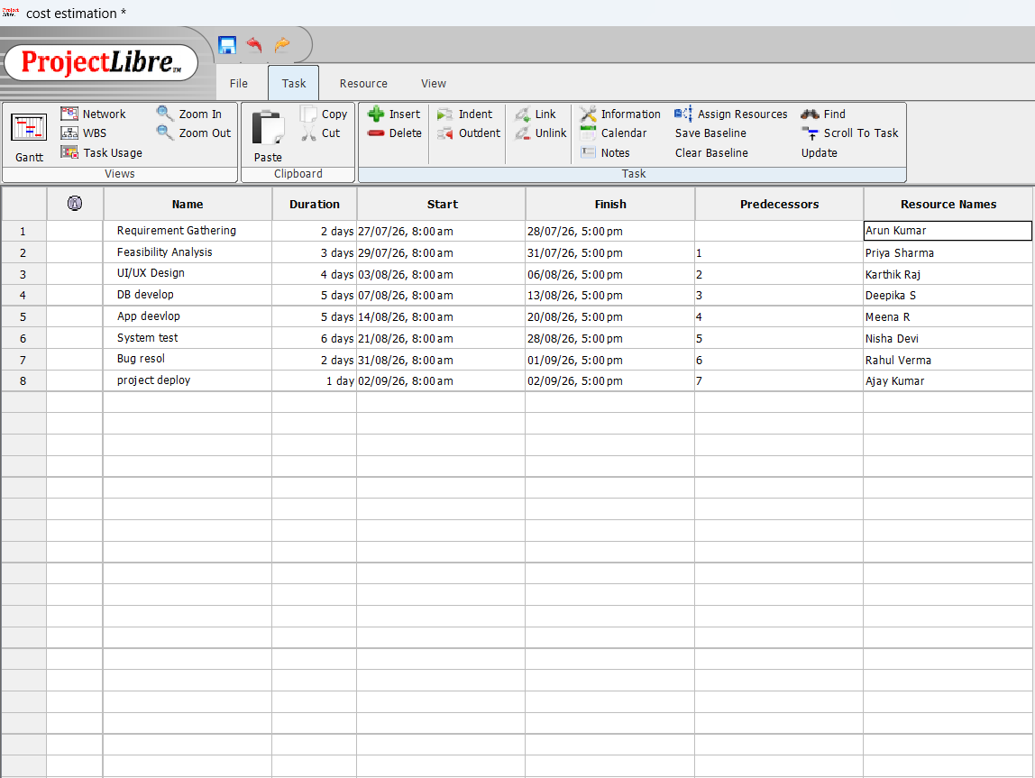

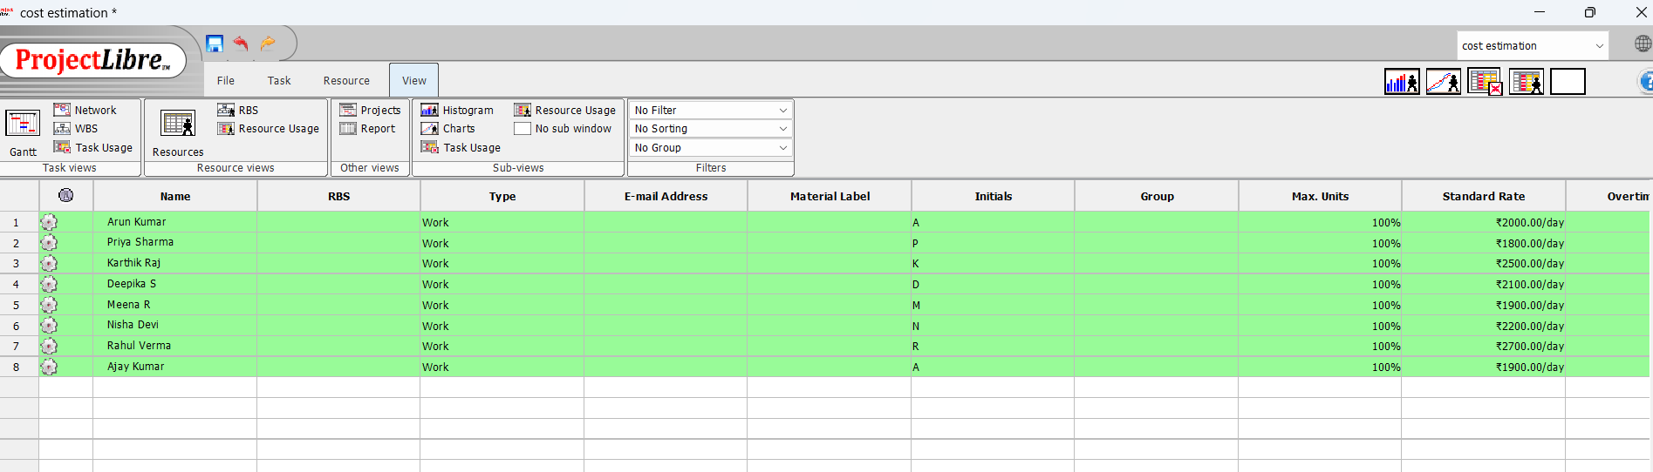

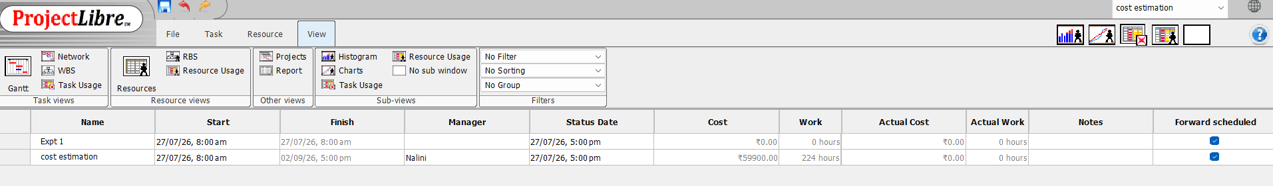

Result:
The project cost estimation was successfully completed using ProjectLibre. The project schedule was created by defining tasks, assigning resources, and specifying their respective costs. The software automatically calculated the estimated project cost of ₹17,500 and generated the Gantt Chart, Resource Sheet, and Cost Report, providing an effective representation of project planning and cost estimation.

